H.T No
Regulations:
A15

Sreenidhi Institute of Science and Technology
(An Autonomous Institution)
Code No: 5A201 Date: 03-Nov-2021 (AN)

B.Tech I-Year II- Semester External Examination, Oct/Nov - 2021 (Supplementary)
CIRCUITS & NETWORKS – I (EEE)

Time: 3 Hours Max.Marks:75

Note: a) No additional answer sheets will be provided.
b) All sub-parts of a question must be answered at one place only, otherwise it will not be valued.
c) Missing data can be assumed suitably.

ANSWER ANY 5 OUT OF 8 QUESTIONS. EACH QUESTION CARRIES 15 MARKS.

Bloom's Cognitive Levels of Learning (BCLL)

Remember | L1 | Apply | L3 | Evaluate | L5
Understand | L2 | Analyze | L4 | Create | L6

 |  |  | BCLL | CO(s) | Marks
1. | a) | Determine v_{x} for the circuit shown in figure  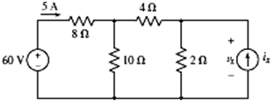 | L5 | CO1 | [8M]
 | b) | Using ∆-Y or Y-∆ conversion, find the current I in the circuit shown in figure  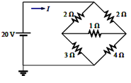 | L5 | CO1 | [7M]
2. | a) | Define the following terms i) Graph ii) Tree iii) Cut set Tie set | L3 | CO2 | [8M]
 | b) | Write short notes on Duality and Dual networks. | L2 | CO2 | [7M]
3. | a) | What is a magnetic circuit? Compare magnetic circuit with an electric circuit. | L2 | CO3 | [8M]
 | b) | Derive the relation between self inductance, mutual inductance and coefficient of coupling. | L3 | CO3 | [7M]
4. | a) | Define the following with respect to sinusoidal quantity  i)RMS Value ii)Average Value iii) Form factor iv) Peak factor. | L1 | CO4 | [8M]
 | b) | Why the net voltage across L and C in a series R-L-C series circuit under resonance is zero | L2 | CO4 | [7M]
5. | a) | Explain the R-L circuit. | L2 | CO5 | [8M]
 | b) | Explain the concept of Band width and Q- factor. | L3 | CO5 | [7M]
6. | a) | Use the superposition theorem to find v in the circuit of below Figure  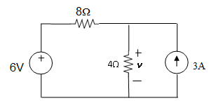 | L3 | CO6 | [8M]
 | b) | Using Norton’s theorem, find R_{N} and I_{N} of the circuit in below Figure at terminals a-b.  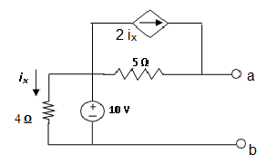 | L3 | CO6 | [7M]
7. | a) | The current in a 15 mH inductor is i = (2 – e⁻¹⁰⁰⁰ t ) mA . What is the voltage across inductor? | L2 | CO1 | [5M]
 | b) | Explain why current lags the voltage by 90⁰ in case of ideal inductor. | L2 | CO2 | [5M]
 | c) | A coil ‘X’ of 1000 turns and another coil ‘Y’ of 2000 turns are placed such that 60% of the flux produced by ‘x’ links ‘y’ .A current of 1A in ‘X’ produces a flux of 0.1mwb in it. Calculate the mutual inductance between the two coils. | L4 | CO3 | [5M]
8. | a) | State and explain the Maximum power transfer theorem. | L1 | CO6 | [8M]
 | b) | Compare AC and DC transients. | L3 | CO4 | [7M]

-- 00 -- 00 –

